H.T No
Regulations:
A17

Sreenidhi Institute of Science and Technology
(An Autonomous Institution)
Code No: 6FC04 Date: 15-July-2021(FN)

B.Tech III-Year II-Semester Pending External Examination, July-2021 (Supplementary)
DESIGN AND ANALYSIS OF ALGORITHMS (ECM)

Time: 3 Hours Max.Marks:75

Note: a) No additional answer sheets will be provided.
b) All sub-parts of a question must be answered at one place only, otherwise it will not be valued.
c) Missing data can be assumed suitably.

ANSWER ANY 5 OUT OF 8 QUESTIONS. EACH QUESTION CARRIES 15 MARKS.

Bloom's Cognitive Levels of Learning (BCLL)

Remember | L1 | Apply | L3 | Evaluate | L5
Understand | L2 | Analyze | L4 | Create | L6

 |  |  | BCLL | CO(s) | Marks
1. | a) | Discuss the various asymptotic notations used for best case, average case and worst case analysis of algorithms. | L3 | CO1 | [8M]
 | b) | Differentiate probabilistic analysis and Amortized analysis with an example. | L4 | CO1 | [7M]
2. | a) | Write Binary search algorithm and analyze its time complexity. | L3 | CO2 | [8M]
 | b) | Implement Strassen’s matrix multiplication for following matrices.  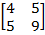 X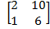 | L5 | CO2 | [7M]
3. | a) | Construct minimum cost spanning tree using Prim’s algorithm.  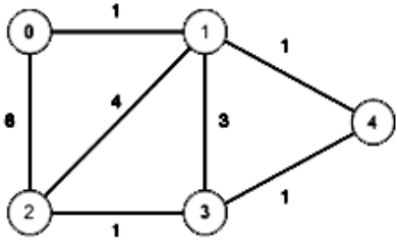 | L6 | CO3 | [8M]
 | b) | Explain 0/1 knapsack problem using Greedy method with an example. | L3 | CO3 | [7M]
4. | a) | Explain Optimal Binary Search Tree algorithm with an example. | L3 | CO4 | [8M]
 | b) | Discuss all pairs shortest path problem with an example. | L3 | CO4 | [7M]
5. | a) | Write an algorithm for Hamiltonian cycle with an example. | L3 | CO5 | [8M]
 | b) | Apply the back tracking algorithm to solve the following instance of the sum of subsets problem S= {5, 10, 12, 13, 15, 18} and d=30. | L4 | CO5 | [7M]
6. | a) | Differentiate between NP-Complete and NP-Hard. | L4 | CO6 | [8M]
 | b) | Explain modular Arithmetic. | L3 | CO6 | [7M]
7. | a) | Define an algorithm and Pseudo code .Write the pseudo code that input n integers and output them in non-decreasing order. | L4 | CO1 | [5M]
 | b) | Explain Space Complexity with an Example. | L3 | CO1 | [5M]
8. | a) | Discuss in detail about travelling sales person problem. | L3 | CO4 | [5M]
 | b) | Differentiate between FIFO and LC branch and bound solution. | L4 | CO5 | [5M]

-- 00 -- 00 –

